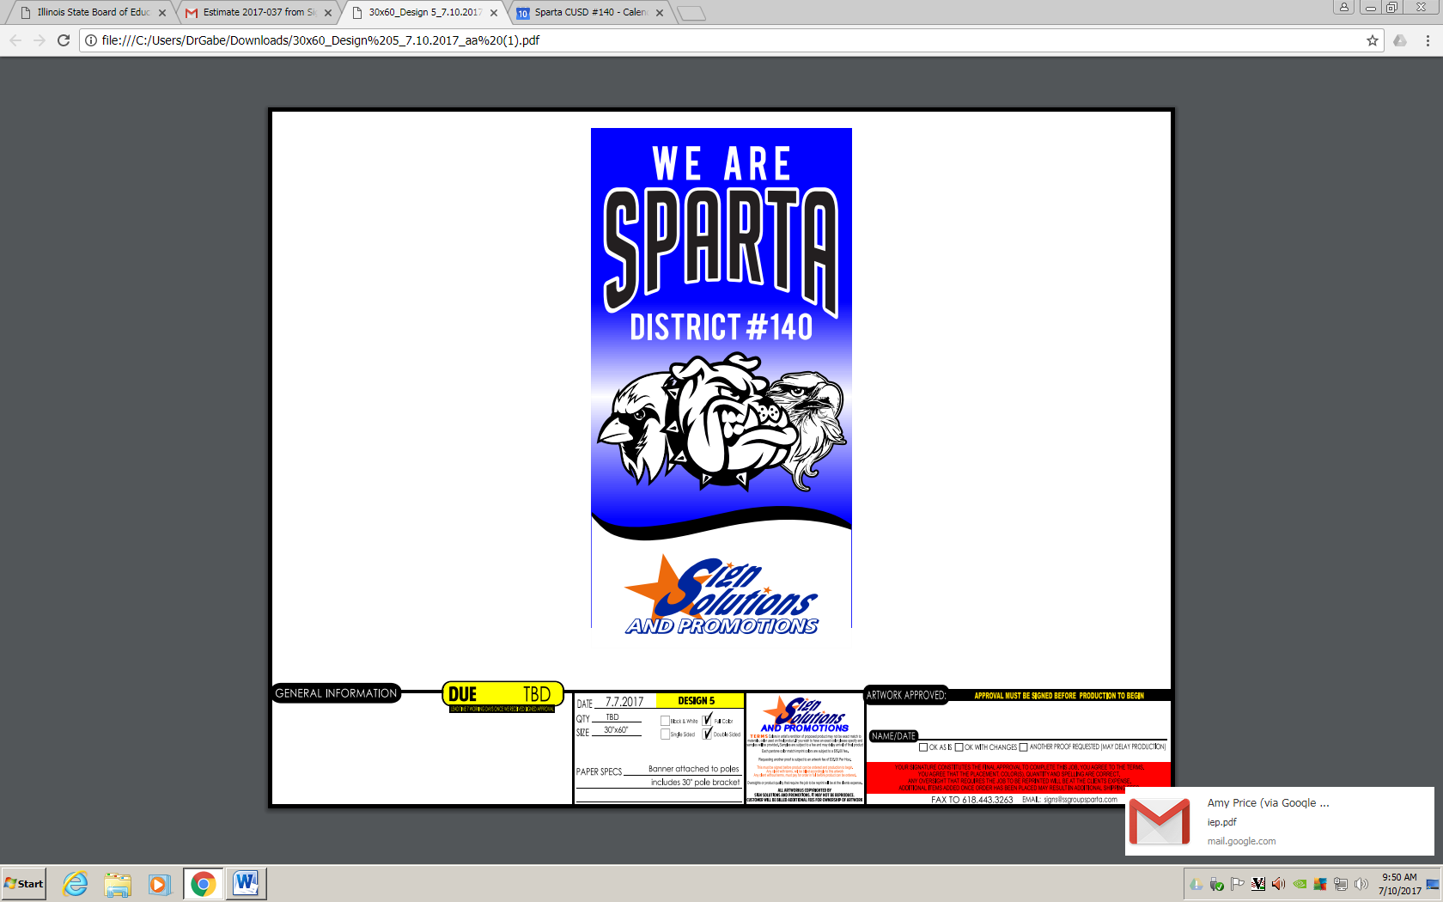



Board of Education

Rheinecker, Holliday, Craig, Byington, Gallois, Kempfer and Young

Superintendent

Dr. Gabrielle Schwemmer

Finance/HR

Tina Witherby, Kay Buch Tracy Stefani

Maintenance/Grounds Keeper

Tracy Smith

SLS Principal

Amy Price

EAC Principal

Chris Miesner

SHS Principal

Scott Beckley

Assistant Principal

Linda Loesing

Assistant Principal

Staci Kramper

Food Service Director/Head Cook

Linda McMaster

Teachers, Paras, Secretaries, Custodians and Supervisors

Cooks

Head Cooks

PC Tech

Joel Finley

Technology Coordinator

Rick Oeth

June 2021 3:30-E